Proudly Presents
4th Zarathushti Unity Cup

“The Field Of Dreams”
San Pedro, California

Saturday and Sunday
September 3rd and 4th, 2005
(Labor Day Weekend)

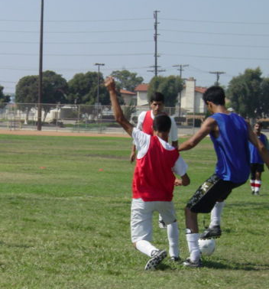
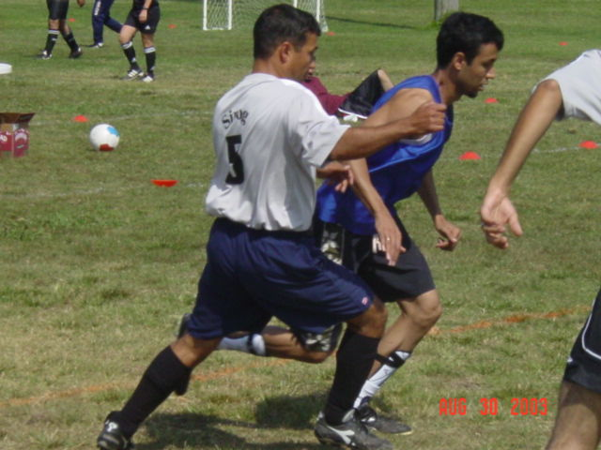

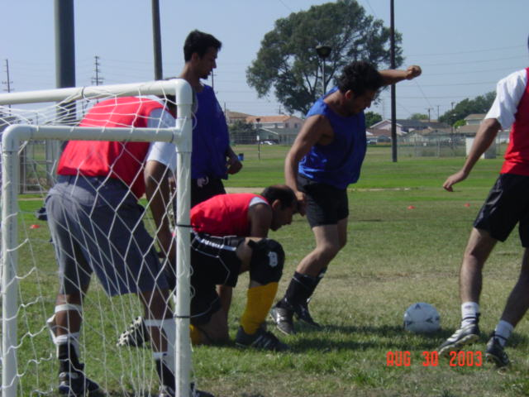
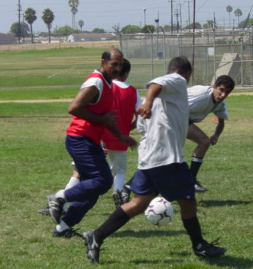

For More Information:
See us at: www.FEZANA.org
or
Email us at: ZSC@FEZANA.ORG

